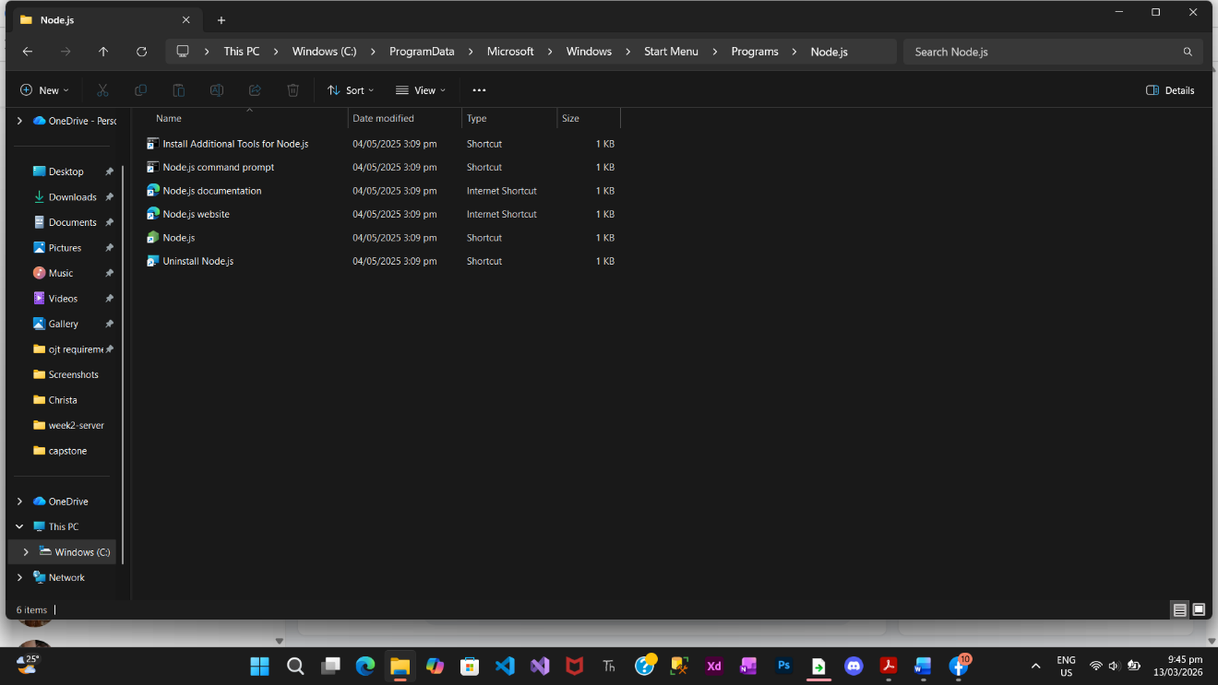

Member:
Manny Cabaya
Kecel Dujali
Melinda Nipes
Shine Tayogandaga
Isabel Ingrid Monarca

